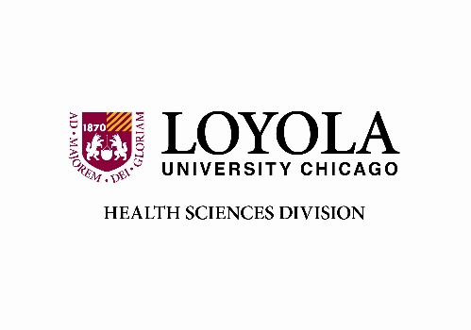

**LOYOLA UNIVERSITY CHICAGO – HEALTH SCIENCES DIVISION**

**RESEARCH FUNDING COMMITTEE**

**2025-2026 Tentative Meeting Dates and Deadlines**

|  |  |
| --- | --- |
| **Deadline Date**  **(@ 5:00pm CST)** | **Meeting Date/Time**  **TBD** |
| Monday, 05/05/2025 | June 2025 |
| Monday, 08/04/2025 | September 2025 |
| Monday, 11/03/2025 | December 2025 |
| Monday, 02/02/2026 | March 2026 |